CS 224 – LAB 3

Execute (EX) Stage

Student Details
- Name: TODO: Fill
- Roll No: TODO: Fill
- Group Number: TODO: Fill
- Date: TODO: Fill

Please note:
Students must be able to explain the code they submit (whether provided or written by them).
If a student cannot explain a component, marks for that component will not be awarded even if it works.
⚠ No marks will be awarded if the block diagram is not shown.

1. Block Diagram (2 marks)

Requirement
Draw the EX stage datapath of a RISC-V processor
📌 Use combinational blocks (decoder, mux, logic) and sequential blocks (registers).
TODO: Paste hand-drawn block diagram image here
☑ ALU operand selection (immediate_sel MUX)
☑ ALU and supported operations
☑ Signed and unsigned subtract / comparison units
☑ Branch comparator logic
☑ Next-PC generation logic
☑ Branch stall logic
☑ EX → MEM/WB pipeline register
TODO: Paste the image of a hand drawn block diagram here

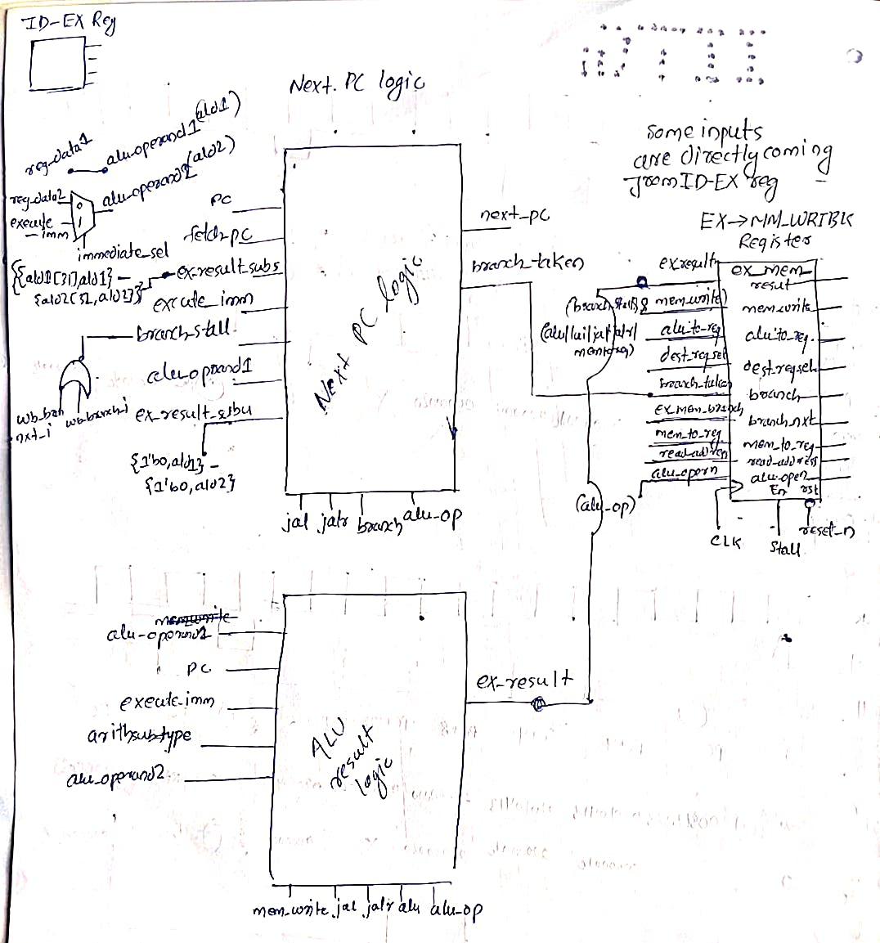

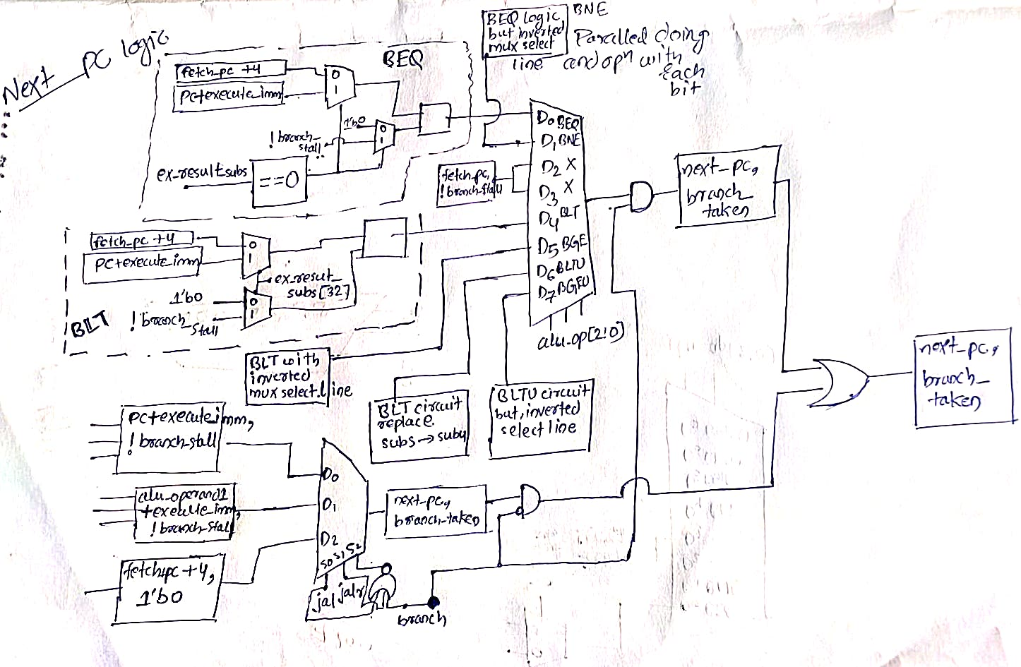

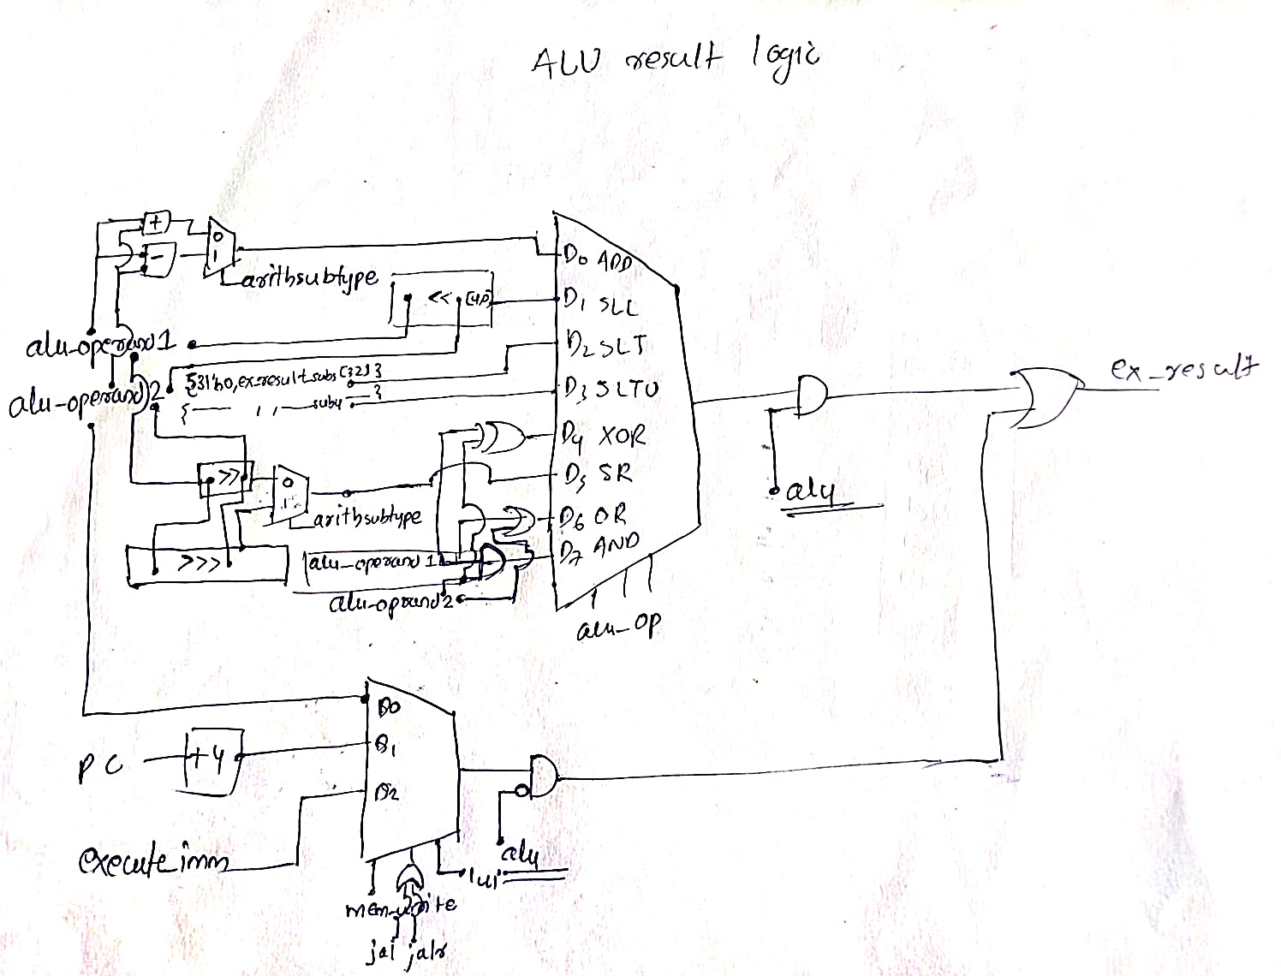

2. Timing Diagram (1.5 marks)

Signals to Show
- clk
- reset
- stall_read
- alu_operand1
- alu_operand2
- wb_result
- branch_taken
- next_pc

Conditions to Demonstrate
- Reset clears EX → MEM/WB registers
- Normal ALU execution
- Branch taken vs branch not taken
- Stall holds pipeline register values
📌 Minimum 10 clock cycles required
TODO: Paste the image of a hand drawn timing diagram here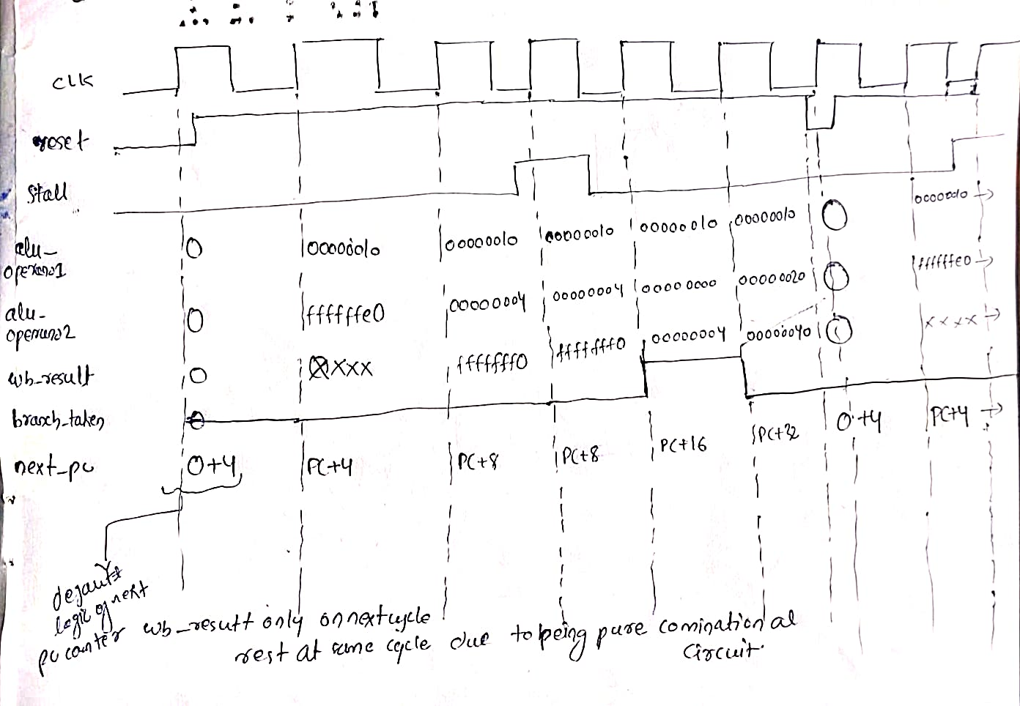

3. Design (2 marks)

Verilog Files Used
- execute.v
- opcode.vh

Design Description
The EX stage:
- Selects ALU operands using immediate_sel
- Performs arithmetic and logical operations
- Evaluates branch conditions (BEQ, BNE, BLT, BGE, BLTU, BGEU)
- Generates next_pc and branch_taken
- Suppresses execution during branch_stall
- Computes memory write address
- Stores results and control signals in EX → MEM/WB registers
- Freezes pipeline state during stall_read

TODO: Add screenshot of your execute.v code (highlighting TODO sections) 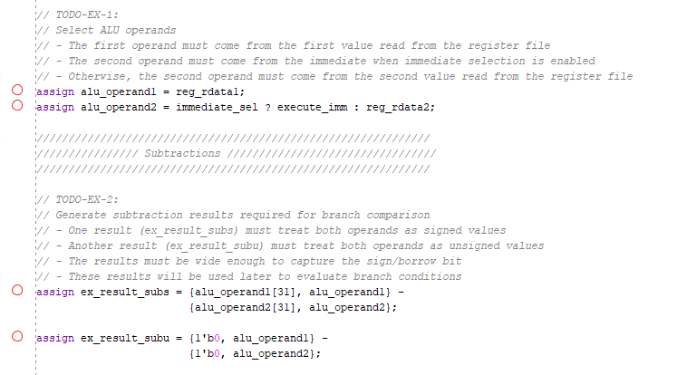
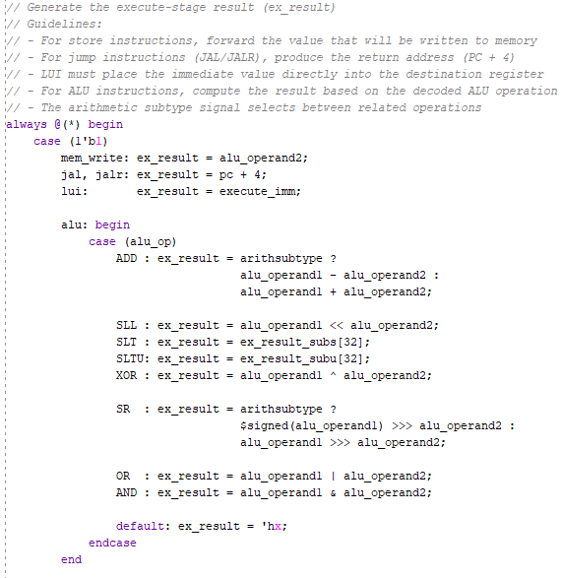

4. Validation Using Simulation (1 marks)

Testbench
- tb_execute.v

Verification Method
- Trace-driven simulation using if_id_output.txt (input)
- Outputs logged to execute_output.txt
- Cycle-by-cycle validation of:
  - ALU result
  - Branch decision
  - Next PC
  - Stall and branch stall behavior

Result
☑ Simulation completed successfully
☑ Output trace matches expected values
TODO: Paste waveform screenshot here

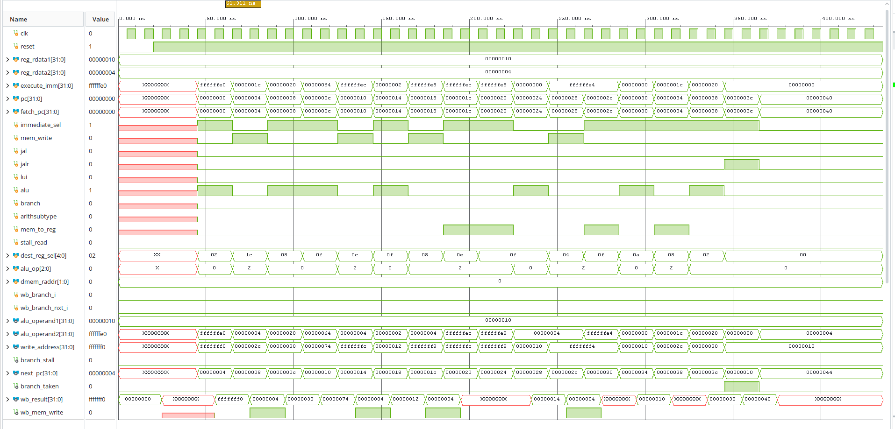

5. FPGA Demo (3 marks)

Hardware Used
- Nexys A7 FPGA Board

Files Used
- top_module.v
- clock_divider.v
- input_ex_b.mem
- constraints.xdc

FPGA Mapping
- Clock → On-board 100 MHz clock (via divider)
- Reset → Push button
- Debug Output → wb_dest_reg_sel (or wb_result[15:0]) on LEDs

Observation
- Execute stage updates only on rising clock edge
- Reset clears EX → MEM/WB pipeline state
- ALU and branch behavior visible on LEDs
- Stimulus sequence repeats correctly
☑ Bitstream generated
☑ FPGA programmed
☑ LED behavior correct
TODO: Add screenshot of the code you have added (in constraints.xdc)
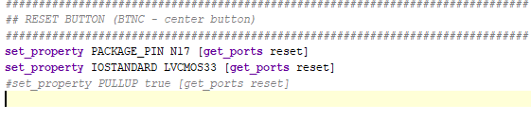
TODO: Add FPGA Screenshot showing the LED output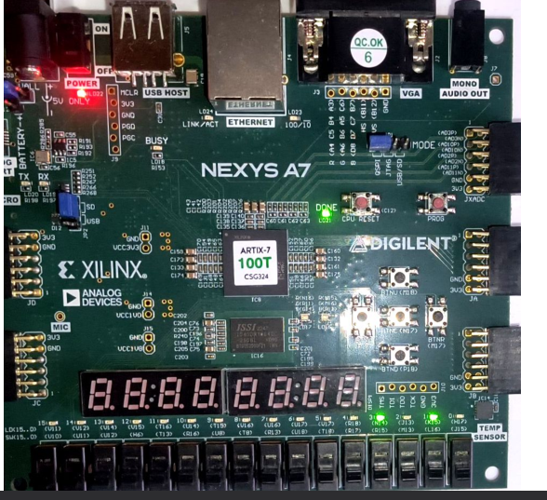

6. Bug Identification (0.5 mark)

Bug Identified / Explained / Fixed

TODO: Briefly describe the bug identified during evaluation
- Reset pin issue D9 -> N17(due to pullup true always remains as 1), had to use active-high reset in top_fpga modules but sending inverted reset to execute.v module(will remain active low).
- Mem file address count correction and it’s corresponding one input size correction.
☑ Bug correctly identified
☑ Explanation / fix provided

